The Complete NPM Tutorial In 2022
Node.js NPM
NPM is a Node Package Manager which is a big repository or a large online store that contains over 1.3 million packages developed by JavaScript users who are called publishers. To serve up the javascript platforms and its technologies.
[contents]
NPM uses two parts to download JavaScript packages:-
- An Online Store that contains all packages of JavaScript.
- Command Line Interface to allow developers download and share their packages in the online repository
JavaScript runtime Node.js is using NPM as a default repository. To run the following NPM commands you have to install NPM

How NPM Works

As we mentioned before, NPM is an online repository that has a lot of JavaScript packages. But we need to know who are uploading and publishing those packages.
Actually, they are developers like you who upload and share their code in the NPM repository. They are called “NPM package authors” or “ Contributors ”. To assist the others who need to use those packages according to their project needs.

NPM is indexing the JavaScript packages according to stats and most of the downloaded packages. To help other developers who need to use those packages according to what is the best one have to use.

NPM helps all developers to save their time by using those javascript packages rather than writing the code from scratch through using some NPM commands

[IMAGE]

The thing that starts with initializing command then going to download needed functionalities inside Node.js modules folder, It is an awesome thing when you find a module in NPM repository saves your time without start from scratch in coding, All of that through a few NPM commands

Sharing and Publishing NPM Packages

NPM Login Command

Firstly, you need to have an account on npmjs.com through this registering page.
Then open terminal or CLI,

- if your OS is windows click on start ( windows icon ) and search about “Command Prompt”

- If the OS is linux ( ubuntu ) or macOs you have to open the system menu then write in search “terminal” word

Next, is the NPM account login access and that can be done using the following command

npm login

When you login with username and password it will send you ( OTP ) to your email, you have to insert it to verify your account .

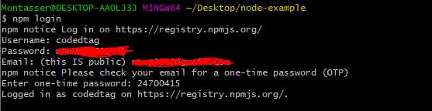

To create project folder and explore it, using CLI you have to write the following commands.

# For create new folder
mkdir eratags-project

# To explore the created folder
cd eratags-project

NPM Init Command

Next step we need, is to create the package.json file and that can be done by using the down below command

npm init

When you run “npm init “ command, It will request you to fill the package.json properties and actually those are information about your project.

NPM Publishing Command
Once you created your package development you’ve to use the following command to share and publish this package on NPM registry

npm publish

The result should be like the below image

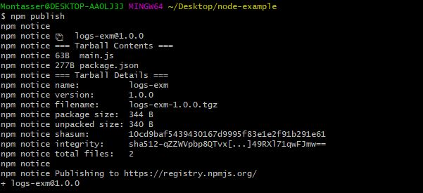

Downloading and Installing NPM Packages

It is very easy to download and install package dependencies, You just have to open the root of your project in CLI then use the below command
npm install <PACKAGE-NAME>

Once you start the command you will see the progress of installing through the CLI or terminal. And there is a new folder added to your project root called “node_modules” with created file “package-lock.json”

When you run “npm install” command without arguments or flags it will list the new property with “dependencies“ object contains the name.

The “node_modules“ Folder
As we mentioned before, The “node_modules” folder is created when we used the “npm install“ command, The purpose of that folder is like a wallet that contains all required packages and needed functionalities that have invocations in your project.

An advice, If you are planning to use git, don’t include the “node_modules” in the git repository. it is very essential for you when you allow git history as a clean sheet.

This means when you add a new package to your project it stores the new changes inside the package.json and package-lock.json, that are bothering the new changes it will consider it as not an old feature of npm.

What is package-lock.json
Package-lock.json file is something like a watcher to detect if the package.json file has changed or not.
As you know the most things that can change in the package.json file are the “version“ property and the "dependency" property.
If values don’t match with the values in package.json the new values of package.json will replace automatically in both files.

What is Package.json

Package.json is the thing like a label of a javascript package that contains all project information. And it can be generated by using the “npm init“ command. It is also considered as a document that has the needed or required specifications for the current package.

When you run “init npm” from the CLI or terminal you will see the following required fields, you have to insert them one by one:-

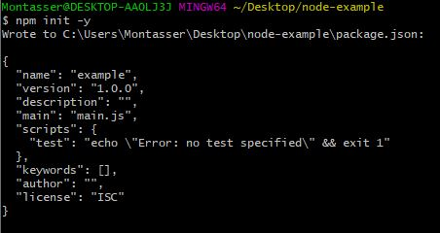

Name: it refers to project or package name
Version: it refers to the version of current package
Main: This property is used to know what is the name of main js file for this package
Description: It describes what the JavaScript package Used for
Keyswords: are many keywords followed by a comma to describe the package

An example for package.json file

[code of package.json]

The Difference Between Dev Dependencies And Dependencies

Dev Dependencies:

DevDependencies Is an object include all the packages or modules those are used in the package or project with its versions which are only needed in the testing and local development not in the production.

The “devDependencies“ object is a property in package.json file like the shown below

DevDependencies:{
"jquery": "^3.6.0",
"serve-static": "^1.14.1"
}

To install any module you need in the local development.

npm install <PACKAGE-NAME> --save-dev

Dependencies:

Dependencies Is an object include all the packages or modules those are needed or required at runtime by your application. So you will not able to work on this project before install those required packages.

The “dependencies” object is a property in package.json file like the shown below

Dependencies:{
"jquery": "^3.6.0",
"serve-static": "^1.14.1"
}

To install any module you need in the production mode.

npm install <PACKAGE-NAME> --production

OR

npm install <PACKAGE-NAME>

Add custom script to package.json file

Scripts property is an object contains many defined shell commands which can be executed by running it during write the below NPM commands.

npm run <SCRIPT-NAME>

OR

npm run-script <SCRIPT-NAME>

The “scripts” object is a property inside package.json file like below

scripts:{
"<SCRIPT-NAME>": "<THE-COMMAND-LINE-SHOULD-BE-HERE>"
}

For Examples, we need to print “CodedTag.com Tutorial “ text in terminal or CLI

scripts:{
"print_me”: "echo \"CodedTag.com Tutorial\" && exit 1"
}

And to execute this example in CLI you have to run the below command

npm run print_me

It will print the results like in the below image

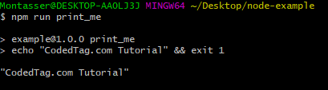

The common uses case for scripts like compiling sass, minifying or start your Node.js server or anything else you want to write in the CLI or terminal related your project.

List Of Useful NPM Commands

NPM Search Command
To searching and finding any npm packages on the npm registry

npm search <PACKAGE-NAME>

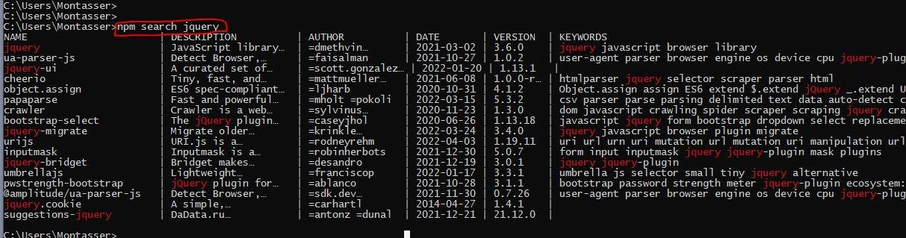

NPM View Command
To watch and view any npm package information like latest published package and version also keywords and a lot informations else

npm view <PACKAGE-NAME>

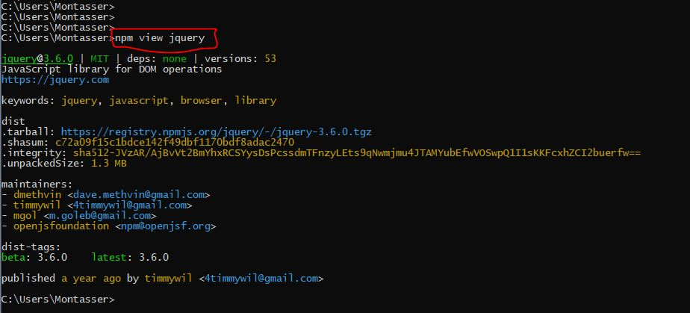

NPM Login Command
Login to your account through email and password this command is sending you an email containing OTP verifying code you have insert it

npm login

npm login command allow npm package authors to share and publish their javascript packages

NPM Install Command
This command to install NPM packages, It effects on package.json , package-lock.json and “node_modules“ folder as we mentioned before.

npm install <PACKAGE-NAME>

NPM Publish Command
To upload and publish your packages on npm registry but you will not able to use this command before login with “npm login“ command

npm publish <PACKAGE-NAME>

NPM Run Command
It runs all scripts are listed on “scripts” object you could able to execute bash commands on your operating system.

npm npm <SCRIPT-NAME>

NPM Build Command
…..

NPM Arguments and Flags

